ECE 661: Computer Vision — Homework 1
Shrikrishna Bhagirath Rajule
srajule@purdue.edu
Purdue University — Fall 2026
September 2, 2026

AI Assistant Usage
AI Usage: ____ %
[ TO FILL IN: replace ____ with your honest estimate, to the nearest per cent ]
An AI assistant was used on this homework. What it did and what I did:
Done by the AI assistant | Done by me
Implementations of vanishing_point_estimates, perpendicular_distance, analyse_families, fit_conic, algebraic_residuals, and the four bonus functions. | Recorded all 44 pixel coordinates by hand, at 200-400 % zoom.
The two helper scripts pick_points.py and wire_points.py, which are not part of the graded solution. | Took the photograph used in Task 1(e), and chose which features in it to measure.
Assembly of this document, and the explanations of the conceptual questions. | Diagnosed and re-recorded a first set of photograph points that were measured on the wrong surface.

Every function listed in the left column says so in its own docstring in hw1_ShrikrishnaRajule.py, as course policy requires.

Task 1(a): Recorded points on tiles.jpg
Tool used: the Matplotlib interactive window, which Section 3.2 of the handout names as an acceptable alternative to GIMP. I drove it through a small script, pick_points.py, that adds a click handler so the coordinates are written to a file rather than copied by hand, and scroll-to-zoom so that every point could be placed at 200-400 % as the handout advises.
Families A and B run along the two grout directions. Family C is the tile diagonals, which are not drawn in the image: for each of those three lines I recorded a corner where four tiles meet, stepped diagonally across the grid counting tiles, and recorded the corner I arrived at.

Family | Line | Point 1 (x, y) | Point 2 (x, y) | Baseline (px)
A tile rows | 1 | (579.2, 383.5) | (909.4, 508.0) | 353
A tile rows | 2 | (510.6, 571.8) | (1119.9, 783.9) | 645
A tile rows | 3 | (662.1, 160.2) | (773.8, 209.7) | 122
B tile columns | 1 | (172.4, 450.5) | (418.1, 227.2) | 332
B tile columns | 2 | (670.1, 624.4) | (705.2, 338.9) | 288
B tile columns | 3 | (1446.9, 748.8) | (1118.3, 366.0) | 504
C tile diagonals | 1 | (451.6, 739.3) | (1057.7, 645.1) | 613
C tile diagonals | 2 | (119.8, 303.8) | (872.7, 381.9) | 757
C tile diagonals | 3 | (848.7, 302.2) | (1009.9, 327.7) | 163
Table 1: the eighteen points recorded on tiles.jpg, in pixel coordinates (column, row), with the separation of each pair.

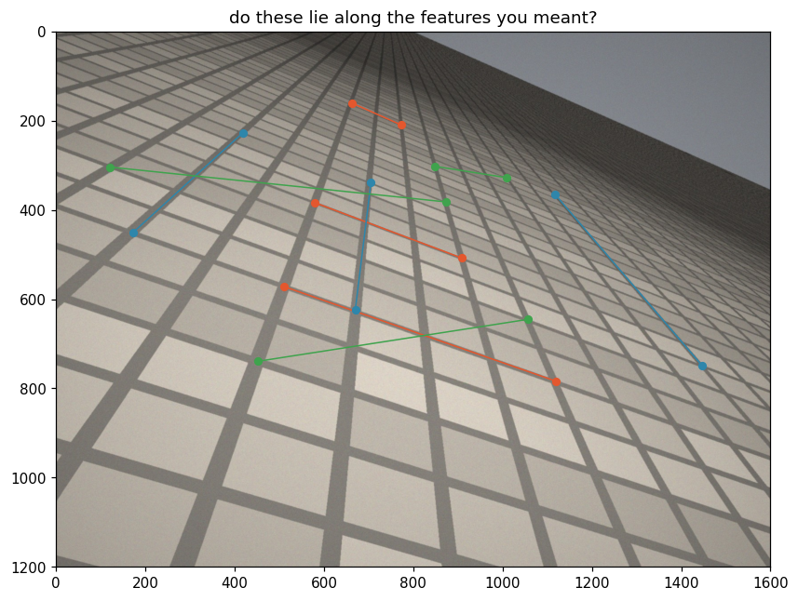
Figure 1: the recorded points drawn on tiles.jpg before anything was computed. This is the only check available on this step, and it is what confirms that the diagonals of family C were counted correctly.

Task 1(b): Vanishing point estimates

Prediction, written before computing anything
[ TO FILL IN: your prediction: which family will give the least reliable vanishing point, and why. Write what you actually believed before you ran the code, not what the numbers below turned out to say. ]

Method
Each recorded pair of points gives a line as the join l = x1 x x2. Three lines give three pairs, and each pair meets in one estimate of the family's vanishing point, v = li x lj. The three estimates are dehomogenized first and averaged second: a homogeneous 3-vector is fixed only up to scale, so the mean of three 3-vectors is not a defined operation, and rescaling one of them would move the answer without moving any of the three points it stands for.
def vanishing_point_estimates(pairs_of_points):
lines = [join(point_a, point_b) for point_a, point_b in pairs_of_points]
estimates = []
for i in range(len(lines)):
for j in range(i + 1, len(lines)):
point = dehom(meet(lines[i], lines[j]))
if point is None:
raise ValueError(
"lines %d and %d of this family meet at an ideal point: "
"they came out exactly parallel in the image, so this "
"family has no finite vanishing point." % (i, j))
estimates.append(point)
estimates = np.array(estimates, dtype=float)
return estimates, estimates.mean(axis=0)

Results
Family | Estimate from lines (1,2) | (1,3) | (2,3) | Spread (px)
A tile rows | (7911.0, 3147.9) | (4512.8, 1866.6) | (5547.5, 2325.2) | 3631.7
B tile columns | (756.8, -80.6) | (744.5, -69.4) | (754.0, -58.3) | 25.4
C tile diagonals | (1999.3, 498.8) | (2045.7, 491.5) | (2266.5, 526.5) | 269.5
Table 2: the three vanishing point estimates per family and their spread, the diagonal of their bounding box.

Family | Mean vanishing point | Distance from centre (800, 600)
A tile rows | (5990.4, 2446.6) | 5509.1
B tile columns | (751.8, -69.5) | 671.2
C tile diagonals | (2103.8, 505.6) | 1307.2
Table 3: each family's mean vanishing point, used everywhere in parts (c) and (d), and its distance from the image centre.

Did the prediction hold?
[ TO FILL IN: one sentence saying whether your prediction held ]
The ordering by spread is B (25.4 px), then C (269.5 px), then A (3631.7 px), a range of a factor of 143. The striking thing is that the spread tracks the distance to the vanishing point monotonically: 671 px out gives a spread of 25 px, 1307 px out gives 270 px, and 5509 px out gives 3632 px.
The mechanism is the conditioning of the meet. The three lines of a family converge at their vanishing point, so a distant vanishing point means the three lines are very nearly parallel in the image. As the angle between two lines goes to zero, the position of li x lj becomes arbitrarily sensitive to the directions of the two lines. A one-pixel error in a recorded point rotates its line through an angle of roughly 1/baseline radians, and that angular error is amplified into a positional error at the intersection in proportion to the distance to it. Family A is the family whose lines are closest to parallel on the sensor, so it is the family whose vanishing point is worst determined.
A second and smaller contribution is baseline length. Line A3 spans only 122 px and line C3 only 163 px, the two shortest pairs in the set, and a short baseline makes the direction of the line noisier before the conditioning effect is applied to it at all.
The measurement hazard that the handout warns about for family C, that a miscounted tile puts a line outside the family, did not materialise. Figure 1 shows the diagonals lying where they were meant to lie, and family C came second rather than last.

Task 1(c): Collinearity of the three vanishing points
Ordered by spread, best determined first: B tile columns (25.4 px), then C tile diagonals (269.5 px), then A tile rows (3631.7 px). The worst determined family is A.
Three points are collinear exactly when the third lies on the line through the other two, so the test is made directly: build the line through the mean vanishing points of B and C as a join, and measure the perpendicular distance from the mean vanishing point of A to it.
def perpendicular_distance(point, line):
a, b, c = line
return abs(a * point[0] + b * point[1] + c) / np.hypot(a, b)

line through the two best mean VPs : [-575.062, 1352.06, 526234]
COLLINEARITY RESIDUAL (perpendicular distance) = 264.943 px

Why the distance and not the determinant
Three homogeneous points are collinear exactly when det[v1 v2 v3] = 0, but the magnitude of that determinant measures nothing. Each vi is fixed only up to scale and the determinant is linear in each column, so rescaling one column rescales the determinant while moving no point at all. The code prints both:
det[v1 v2 v3] with each v_i as [x, y, 1]^T : 389273
the same determinant after scaling v3 by 1e6 : 3.89273e+11
Same three points, same picture, a determinant six orders of magnitude larger. The determinant can answer the question "is this exactly zero?", and nothing else; with measured points it is never exactly zero, so on real data it answers nothing. The perpendicular distance divides by the norm of (a, b), so every scale factor cancels and what is left is a genuine length in pixels. That is a number that can be compared against the size of the image, against my own click precision, and against the same quantity computed on a different photograph, which is exactly what part (e) does.

What the number says about the claim
The claim under test is that the vanishing points of different families of parallel lines lying in one plane of the world are collinear. The residual of 264.94 px is about 4.8 % of the 5509 px distance from the image centre to the vanishing point being tested, and the point itself is one whose three estimates already disagree among themselves by 3632 px. On that scale the three vanishing points are collinear to within my recording error, and the claim survives the test.
What would have falsified it is a residual that did not shrink as recording precision improved, or one comparable to the separation between the vanishing points themselves, which here is several thousand pixels. A residual of that size would have meant the three points were not on a common line at all, rather than being on one and measured imprecisely.

Task 1(d): The vanishing line
The vanishing line is the join of the two best determined vanishing points, those of families B and C. The worst determined one, A, is deliberately left out of it, since it is the point whose distance to this line part (c) reports.
l_v = join(VP B, VP C)
l_v = [-575.062, 1352.06, 526234]
l_v normalized to a^2 + b^2 = 1 : [-0.391393, 0.920224, 358.16]
vanishing points that land inside the frame : 0 of 3
All three vanishing points fall outside the frame, and the most distant is 5509 px from the image centre of a 1600 x 1200 image, so no single set of axis limits shows both the picture and that point usefully. Two panels are used.
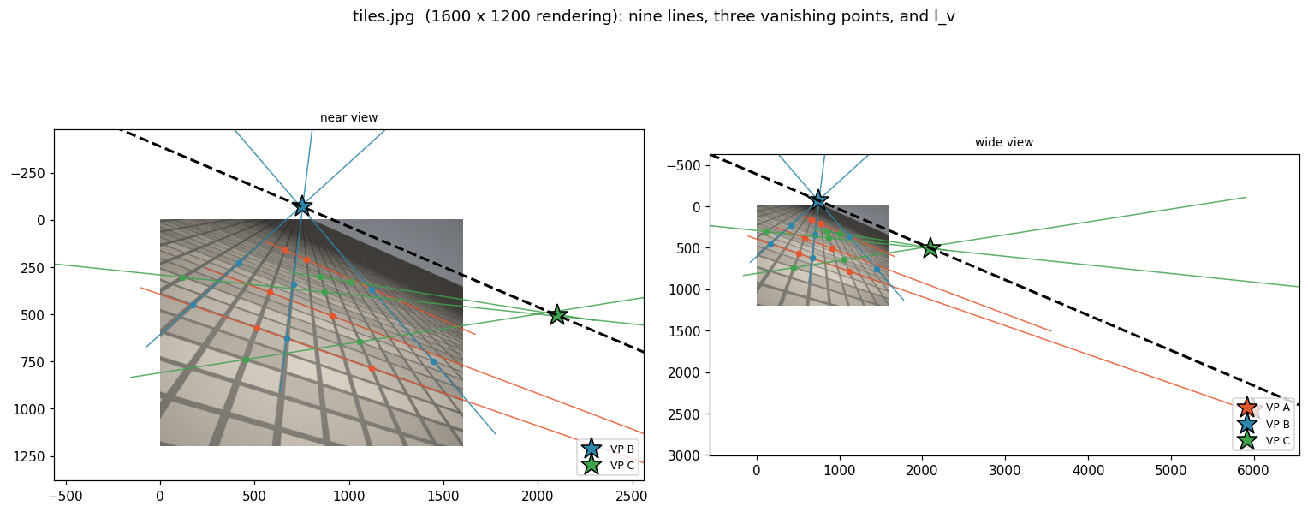
Figure 2: the nine recorded lines extended, the three vanishing points and the vanishing line l_v. Left, a near view holding the image and the two nearer vanishing points; right, a wide view holding all three.

The degenerate case
The case that a Cartesian implementation would have to special-case is not the vanishing point being far away. A distant vanishing point is an ordinary pair of large numbers and any implementation handles it. The case is the limit just beyond that: two lines of a family that come out exactly parallel in the image. Solving for their intersection in Cartesian coordinates means solving a 2x2 linear system whose determinant is then zero, so the Cartesian code must detect that and branch.
The cross product needs no branch. l1 x l2 returns [a, b, 0], a perfectly ordinary homogeneous 3-vector that happens to have a zero third entry, and it is the ideal point in the common direction of the two lines. Nothing failed and nothing had to be detected: the point at infinity is a point like any other in this representation, which is the whole reason for adopting it.

Where a test is still needed
The test does not disappear; it moves. It is needed at the moment of returning to Cartesian coordinates, which is what dehom() does. There it must be decided whether the third entry is negligible, and the point worth making is that this cannot be done by asking whether x3 is small. A homogeneous vector is fixed only up to scale, so multiplying the whole vector by a thousand makes x3 a thousand times larger without moving the point it names. The test has to be relative to the other two entries, which is exactly what the supplied dehom() does.
def dehom(x, eps=1e-9):
if not np.any(x):
return None
scale = max(abs(x[0]), abs(x[1]))
if abs(x[2]) <= eps * scale:
return None
return x[:2] / x[2]
So the difficulty never lived in the intersection at all. It lives at the boundary where projective space is left and a finite pair of numbers is demanded, because that is the only place where the distinction between a finite point and an ideal point has any consequence.

Task 1(e): The same measurements on my own photograph
The photograph is a tiled floor in a corridor, shot obliquely so that the grout lines visibly converge. It is 4624 x 2084 pixels, so the image centre is (2312, 1042). All eighteen points were recorded on the floor grout: the floor is one plane of the world, which is what the task requires, and features not lying in it, such as the recessed air vent visible on the left of the frame, were avoided.

Family | Line | Point 1 (x, y) | Point 2 (x, y) | Baseline (px)
A first family | 1 | (2440.1, 882.2) | (3146.4, 856.4) | 707
A first family | 2 | (2185.3, 1704.6) | (3298.0, 1711.1) | 1113
A first family | 3 | (3114.1, 640.3) | (3768.8, 592.0) | 656
B second family | 1 | (3207.7, 1182.2) | (3085.1, 463.0) | 730
B second family | 2 | (3643.1, 424.3) | (4607.4, 1714.3) | 1611
B second family | 3 | (2559.4, 504.9) | (2501.4, 669.4) | 174
C third family | 1 | (3207.7, 1182.2) | (3768.8, 595.2) | 812
C third family | 2 | (4230.0, 375.9) | (3933.3, 808.1) | 524
C third family | 3 | (3117.4, 650.0) | (3626.9, 417.8) | 560
Table 4: the eighteen points recorded on my own photograph.

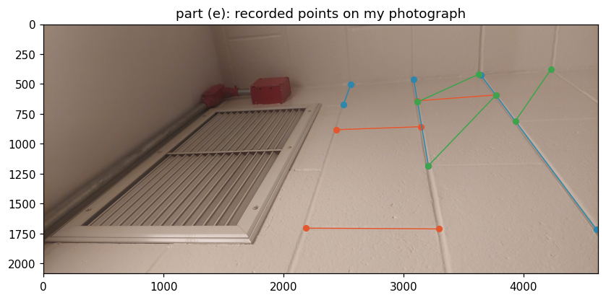
Figure 3: the recorded points on my photograph, checked before computing. All three families lie on the floor grout.

Family | Estimate from lines (1,2) | (1,3) | (2,3) | Spread (px)
A first family | (-17005.0, 1592.5) | (-2719.6, 1070.7) | (-10322.0, 1631.5) | 14296.4
B second family | (2911.7, -554.1) | (2918.6, -513.8) | (2926.0, -535.0) | 42.8
C third family | (4871.1, -558.0) | (4178.8, 166.3) | (4462.7, 36.9) | 1001.9
Table 5: the three vanishing point estimates per family and their spread, on my own photograph.

Family | Mean vanishing point | Distance from centre (2312, 1042)
A first family | (-10015.5, 1431.6) | 12333.7
B second family | (2918.8, -534.3) | 1689.1
C third family | (4504.2, -118.3) | 2480.3
Table 6: mean vanishing points on my own photograph.

Ordered by spread, best determined first: B (42.8 px), then C (1001.9 px), then A (14296.4 px). The pattern of part (b) repeats exactly: spread tracks distance to the vanishing point monotonically, 1689 px out giving 42.8 px of spread, 2480 px giving 1002 px, and 12334 px giving 14296 px.
l_v = join(VP B, VP C)
l_v = [-416.024, 1585.43, 2.06137e+06]
l_v normalized to a^2 + b^2 = 1 : [-0.253812, 0.967254, 1257.62]
COLLINEARITY RESIDUAL (perpendicular distance) = 5184.366 px
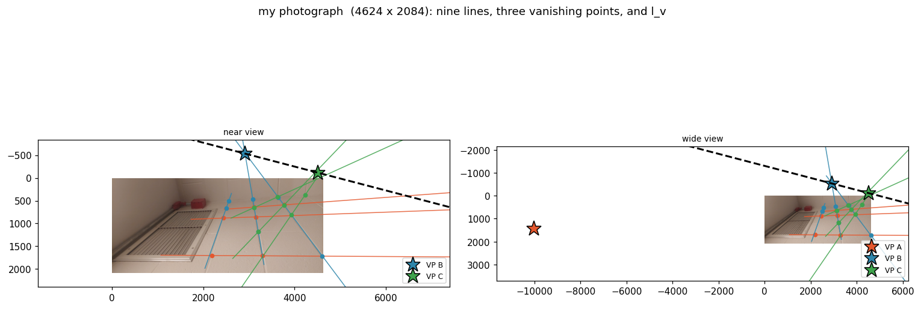
Figure 4: the nine lines, three vanishing points and vanishing line on my own photograph. Again none of the three vanishing points lands inside the frame, so two panels are used.

Comparison of residuals
Image | Collinearity residual | Ratio
tiles.jpg (rendering, exact pinhole) | 264.94 px | 1x
myphoto.jpg (real camera) | 5184.37 px | 19.6x worse
Table 7: the collinearity residual on the supplied rendering and on my own photograph.

The residual on my photograph is 19.6 times worse, as expected. I want to be careful about attributing all of it to the lens, because on this particular photograph it is not the largest effect.

The largest effect here is the viewpoint, not the lens
The three lines of family A run within about 4.5 degrees of each other in the image, at directions of -2.1, +0.3 and -4.2 degrees. That family is very nearly parallel on the sensor, so by the conditioning argument of part (b) its vanishing point is badly determined: it lands at (-10015, 1432), which is 12334 px from the centre of a 4624 px wide frame, and its three estimates disagree by 14296 px. The point whose distance to the line I am reporting is that point. I photographed the floor with one tile direction almost parallel to the image plane, and that choice, rather than the optics, sets the scale of the 5184 px figure.
This is also an accidental near-example of the degenerate case named in part (d). Family A is close to the limit where its vanishing point stops being a finite point and becomes an ideal point, and the enormous spread is what approaching that limit looks like in measured data.

The lens-related reason
tiles.jpg is a computer rendering, produced by an exact pinhole projection. Under a pinhole camera a straight line in the world images to a straight line, so the collinearity of vanishing points holds there up to my click precision and nothing else.
A real camera has a lens, and a real lens has radial distortion, barrel or pincushion, growing with distance from the optical axis. Under radial distortion a straight line in the world no longer images to a straight line, it images to a slight curve. The consequences run right through the calculation: the two points I record on a grout line no longer define the true image of that line, the three lines of a family are no longer exactly concurrent, and the vanishing points move, most of all for lines recorded near the edge of the frame. Collinearity of vanishing points is a consequence of the projective camera model, and radial distortion is precisely a departure from that model, so it is the right place to look for a systematic residual.

Telling the lens apart from careless recording
The distinguishing property is that lens distortion is systematic and structured while careless recording is random. Any of these three tests separates them:
- Record the same eighteen points a second time and recompute. Careless recording gives a different residual each time, scattered about zero. Distortion gives substantially the same residual, because the error is a fixed function of position in the frame rather than of the moment of clicking.
- Record only near the centre of the frame. Radial distortion falls off toward the optical axis, so the residual should shrink markedly. Recording error does not care where in the frame a point is, so it would not.
- Record many points along one long grout line and fit a straight line to them. Under distortion the residuals of that fit are smooth and systematically signed, all bowing the same way. Under careless recording they are random in sign.

Task 2(a): Recorded points on the rim of plate.jpg
Eight points were recorded around the outer edge of the plate, where it meets the table, spread right around the boundary rather than bunched on one arc. Points from the inner ring, where the glaze changes shade, were excluded: that is a second and smaller circle, and points from both boundaries would not lie on any one conic.

# | x | y | # | x | y
1 | 515.4 | 592.5 | 5 | 1111.9 | 559.0
2 | 665.3 | 479.3 | 6 | 965.2 | 707.4
3 | 848.7 | 418.6 | 7 | 778.6 | 775.9
4 | 1022.6 | 425.0 | 8 | 539.3 | 760.0
Table 8: the eight rim points recorded on plate.jpg.

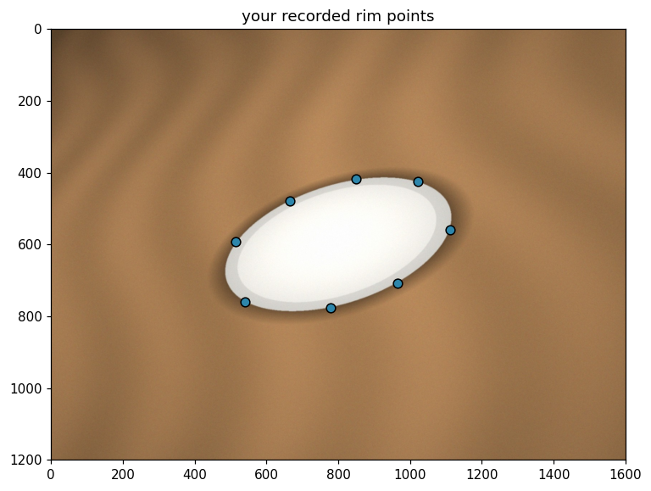
Figure 5: the eight recorded rim points on plate.jpg.

Task 2(b): Fitting the conic
Each point on a conic contributes one row [x^2, xy, y^2, x, y, 1] to a design matrix A, so that A c = 0 holds for a coefficient vector c describing a conic through all of them. Because C is fixed only up to scale there is nothing to solve for in the usual sense: what is wanted is the null direction of A, and with eight noisy measured points that is the right singular vector belonging to the smallest singular value, which is the last row of Vt from numpy.linalg.svd.
def fit_conic(points):
p = np.asarray(points, dtype=float)
x, y = p[:, 0], p[:, 1]
design = np.column_stack([x * x, x * y, y * y, x, y, np.ones_like(x)])
_, singular_values, vt = np.linalg.svd(design)
coefficients = vt[-1] # null direction of the design matrix
C = coefficients_to_matrix(coefficients)
return C / np.linalg.norm(C), singular_values

singular values of the design matrix:
2.72e+06 7.109e+05 7.011e+04 349.7 53.22 0.0007365
The smallest singular value is about five orders of magnitude below the next one up, so the null direction is cleanly separated and the fit is well determined.

C, scaled so that ||C||_F = 1:
[ 0.00000044 0.00000031 -0.00053853]
[ 0.00000031 0.00000127 -0.00100968]
[ -0.00053853 -0.00100968 0.99999869]
||C||_F = 1.000000
max_i |x_i^T C x_i| = 4.783026e-04
The residual is 4.78 x 10^-4, inside the 10^-3 to 10^-4 range the handout gives as the expected order.

What that number measures, and why it is not a distance
It is the algebraic residual: how far each recorded point is from satisfying the equation of the conic, not how far it lies from the curve in the image. x^T C x is a quadratic form in pixel coordinates, so its units are pixels squared times whatever units C carries, and C's scale was fixed by an arbitrary convention, ||C||_F = 1. Fixing that scale is not optional, because x^T C x is linear in C: without a stated convention the reported number could be made any value at all simply by multiplying C by a constant, which changes no geometry whatsoever.
Even with the scale fixed the number is not a length. The same point at the same geometric distance from the curve gives a different x^T C x depending on where around the conic it sits, because the quadratic form grows at different rates where the curve is sharply bent than where it is flat. The genuinely geometric quantity would be the distance from the point to the nearest point of the conic, which has no closed form and is not what this fit minimises.

Task 2(c): Classification
Rescaling the coefficient vector so that a^2 + b^2 + c^2 = 1 fixes the scale of the discriminant, which would otherwise be multiplied by the square of any rescaling.
a = 0.2991140 b = 0.4134745 c = 0.8599824
d = -727.2083607 e = -1363.4234621 f = 675172.0892562
check a^2 + b^2 + c^2 = 1.000000000
discriminant b^2 - 4ac = -0.857970
classification: ellipse
The discriminant is negative, so for a nondegenerate real conic this is an ellipse, which is what a circle seen obliquely should be. The value of -0.858 matches the -0.86 the handout gives as the expected figure for plate.jpg.

the two circle constraints, neither of which survives:
b = 0.4134745 (a circle needs 0)
a - c = -0.5608683 (a circle needs 0)

Why a camera should not be expected to preserve those relations
The object is a circle in the world plane, and in a Euclidean Cartesian frame a nondegenerate conic is a circle exactly when b = 0 and a = c. That is a statement about the coefficients in one particular frame, not a property the curve carries around with it.
The image plane is related to the world plane by a projective transformation H, and under it a conic transforms as C -> H^-T C H^-1. That congruence mixes all six coefficients together: every entry of the new matrix is a combination of every entry of the old one, with weights set by H. The relations b = 0 and a = c are preserved only by the similarity transformations, rotation, uniform scaling and translation, which are the ones that preserve angles. A camera in general position is not a similarity, it is a full projectivity with the plane's vanishing line at a finite distance, so there is no reason for those two particular relations among individual entries of C to survive, and they do not.

What did survive
Being a conic at all. x^T C x = 0 maps to an equation of the same form, so the curve is still described by a quadratic in the image.
Being nondegenerate. H is invertible, so C of rank 3 maps to a matrix of rank 3.
Being an ellipse specifically. The whole circle lies on the camera's side of the plane's vanishing line, so no point of it is sent to infinity and the closed bounded curve stays closed and bounded. Had the vanishing line cut through the circle, part of it would have been sent to infinity and the image would have been a hyperbola; had it touched the circle, a parabola. The classification is therefore not an accident of this photograph but a consequence of the whole plate being visible in front of the camera.
Tangency survived as well, which is what part (d) checks, and so did incidence generally: a point on the curve maps to a point on the curve. What is lost is everything metric. The radius has no image, the image of the circle's centre is not the centre of the image ellipse, and the equality of all diameters is gone.

Task 2(d): The tangent at a recorded point
The matrix C is symmetric by construction, since the xy, x and y coefficients are split evenly across the off-diagonal pairs. The tangent to the conic at a point p lying on it is l = C p, with equality up to a nonzero scale factor: l is a homogeneous line and any nonzero multiple of C p names the same line.
p = (515.4, 592.5)
l = C p = [-0.00012878032, -9.7189636e-05, 0.12419972]
p^T C p = 2.414848e-04
l^T p = 2.414848e-04
difference between the two = 0.000000e+00
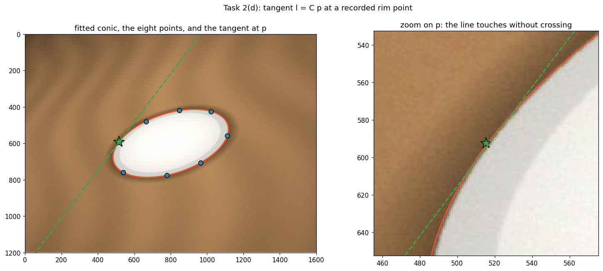
Figure 6: the fitted conic, the eight recorded points and the tangent at p. Left, the whole image; right, zoomed on p, where the line can be seen touching the curve without crossing it.
The zoomed panel is the check that matters. The fitted conic follows the outer rim of the plate all the way round, and at p the tangent touches the curve and does not cross it.

Why p^T C p and l^T p must agree
By definition l = C p, so l^T p = (C p)^T p = p^T C^T p. C is symmetric, so C^T = C and therefore l^T p = p^T C p. The two expressions are the same expression, rewritten using the symmetry of C.

Why their agreeing verifies nothing
Because it is an identity. It holds for any symmetric 3 x 3 matrix and any vector p, whatever they are. It does not require that C came from a good fit, or from a fit at all; it does not require p to lie on the conic, or anywhere near the plate; it does not require the SVD to have converged on anything sensible. Substituting a random symmetric matrix and a random point reproduces the agreement exactly, to machine precision, every time.
What the check does confirm is that C really is symmetric and that the matrix multiplication was coded correctly. What it cannot confirm is anything at all about whether the conic follows the rim of the plate. That is what Figure 6 is for, and in particular the zoomed panel, which is the only test in this task that could actually have failed.

Bonus (a): The aiming line and the two subtended intervals
The aiming line for angle alpha is the join of the origin with a point one unit away in the direction alpha, which comes out as l(alpha) = [-sin alpha, cos alpha, 0]^T.
def aiming_line(alpha_in_degrees):
alpha = np.radians(alpha_in_degrees)
return join((0.0, 0.0), (np.cos(alpha), np.sin(alpha)))

aiming line at alpha = 0.0 deg : [ 0.000000, 1.000000, 0.000000]
aiming line at alpha = 45.0 deg : [-0.707107, 0.707107, 0.000000]
aiming line at alpha = 90.0 deg : [-1.000000, 0.000000, 0.000000]
Alpha appears in the first two entries only. The third entry is zero because every line through the origin satisfies a*0 + b*0 + c = 0, which forces c = 0. Note also that alpha and alpha + 180 degrees give the same line up to the scale factor -1: the line carries no direction at all, which is the fact part (b) turns on.

target subtends : [69.4440, 82.8750] deg
armour subtends : [38.6598, 84.2894] deg
The target's interval is contained in the armour's, but containment on its own does not establish that the target is unreachable: it shows only that any ray reaching the target also meets the armour's line somewhere, not that it meets the armour before reaching the target. The armour is met first because it is nearer. Concretely, for every angle in the target's interval the ray crosses y = 4 at an x between 0.5000 and 1.5000, which lies inside the armour's span of x from 0.4 to 5.0, and y = 4 is crossed on the way to y = 8. So the shot is stopped at the armour and no direct shot at the target exists.

aiming line at 45 deg met with l_inf = [0,0,1]^T :
[ 0.707107, 0.707107, -0.000000] -> dehom() gives None
Meeting the aiming line with the line at infinity gives an ideal point, namely [cos alpha, sin alpha, 0]^T up to scale, which is the direction of the ray itself. dehom() correctly returns None for it. Part (d) uses this. Note that [0, 0, 1]^T names two different things here: read as a point it is the origin, read as a line it is the line at infinity. That is duality, not a typographical error.

Bonus (b): The naive hit test and the missing condition
def strikes_segment(segment, alpha_in_degrees, use_direction_test=True):
segment_line = join(segment[0], segment[1])
q = dehom(meet(segment_line, aiming_line(alpha_in_degrees)))
if q is None:
return False, None # parallel: they meet at infinity
## Is the meet between the endpoints? Project onto the segment.
a, b = np.asarray(segment[0], float), np.asarray(segment[1], float)
t = np.dot(q - a, b - a) / np.dot(b - a, b - a)
between = -1e-9 <= t <= 1.0 + 1e-9
if not use_direction_test:
return between, q
alpha = np.radians(alpha_in_degrees)
direction = np.array([np.cos(alpha), np.sin(alpha)])
return bool(between and np.dot(direction, q) > 0.0), q

meet of the aiming line with the target's line : (2.9118, 8.0000)
naive test (between the endpoints only) : True
d . q = -8.5134 -> the meet is BEHIND the player
corrected test (adds d . q > 0) : False
At alpha = 250 degrees, which points down and to the left, away from everything on the board, the naive test reports a hit on the target. The diagnosis is exactly the observation of part (a): alpha appears only in the first two entries of the aiming line, and l(250) and l(70) differ only by an overall factor of -1. They are the same line. A line has no direction, so it runs backwards through the target just as readily as forwards, and the meet at (2.9118, 8.0000) is a real intersection of the line with the target, just one that lies behind the player.
The missing condition is a ray-direction test, not an adjustment to how the angle is bookkept. With d = (cos alpha, sin alpha)^T and q the meet in Cartesian coordinates, the shot travels forwards only when d^T q > 0. Here d^T q = -8.5134, which is negative, and the corrected test reports no hit.
The inequality is strict. d^T q = 0 is the case where the meet lies on the line through the player perpendicular to the aiming direction, which for a ray starting at the player means the meet is at the player's own position, at zero range. That is not a forward hit, so the boundary case must be excluded rather than included.

Bonus (c): The reflection in the wall x = 7
A reflection in the line l = [a, b, c]^T with a^2 + b^2 = 1 is M = I - 2 n~ l^T with n~ = [a, b, 0]^T. The reason is that ax + by + c is the signed distance to the line when a^2 + b^2 = 1, and (a, b) is the unit normal, so subtracting twice that distance along the normal is a reflection. Writing the normal as an ideal point [a, b, 0]^T is what allows the same matrix to reflect directions as well as points, which part (d) relies on.
def reflection_in_line(l):
l = np.asarray(l, dtype=float)
norm = np.hypot(l[0], l[1])
if abs(norm - 1.0) > 1e-9:
print(" [reflection_in_line: a^2 + b^2 = %.6f, not 1; normalizing]"
% (norm ** 2))
l = l / norm
n_tilde = np.array([l[0], l[1], 0.0])
return np.eye(3) - 2.0 * np.outer(n_tilde, l)

l_wall normalized to a^2 + b^2 = 1 : [-1.000000, 0.000000, 7.000000]
M = M @ M =
[-1.000000 0.000000 14.000000] [ 1.000000 0.000000 0.000000]
[ 0.000000 1.000000 0.000000] [ 0.000000 1.000000 0.000000]
[ 0.000000 0.000000 1.000000] [ 0.000000 0.000000 1.000000]
||M @ M - I||_F = 0.00e+00
M^2 = I had to be true because reflecting twice in the same line returns every point to where it started. A reflection is its own inverse, an involution, so its matrix must square to the identity.

Bonus (d): The bank shot
The centre of the target bar is (2, 8). Reflecting it in the wall gives its mirror image, and aiming at that mirror image gives the angle whose ricochet reaches the bar.
target centre : (2.0000, 8.0000)
its mirror image in the wall : (12.0000, 8.0000)
aim at the mirror image: alpha = 33.690068 deg
Tracing the ray leg by leg, rather than trusting the construction:

Leg | Quantity | Value | Check
1 | crosses y = 4 at x = | 6.0000 | armour spans x in [0.4, 5.0]: clears it
1 | strikes the wall at | (7.0000, 4.6667) | wall spans y in [0, 6]: hits it
- | incoming direction | [0.832050, 0.554700, 0] | an ideal point
- | reflected by M | [-0.832050, 0.554700, 0] | third entry still 0
2 | lands on y = 8 at x = | 2.000000 | bar spans x in [1, 3]: hits it
2 | error from bar centre | 3.11e-15 | machine precision
Table 9: every intermediate number of the two-leg trace.

The direction was reflected by applying M to the ideal point [cos alpha, sin alpha, 0]^T computed in part (a). The translation column of M, the 14 in the top right, multiplies the third coordinate, which is zero, so it drops out and what comes back is a pure direction rather than a translated point. A direction is an ideal point, which is why one matrix serves for both jobs, and why part (a) was worth doing.
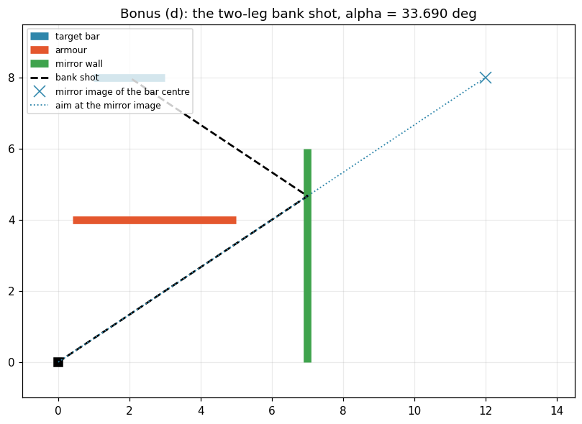
Figure 7: the two-leg bank shot on the arena. The dotted line is the aim at the mirror image of the bar centre; the dashed line is the actual path, clearing the armour, striking the wall at (7, 4.667) and returning to the centre of the target bar.

References
- Course notes, ECE 661 Computer Vision, Lecture 2: homogeneous coordinates for points and lines, meet and join as cross products, ideal points and the line at infinity, conics and the tangent line. Purdue University, Fall 2026.
- ECE 661 Homework 1 handout, Fall 2026, including the expected check values quoted in Tasks 2(b) and 2(c).
- R. Hartley and A. Zisserman, Multiple View Geometry in Computer Vision, 2nd edition, Cambridge University Press, 2004, chapter 2.
- NumPy Developers, numpy.linalg.svd documentation, https://numpy.org/doc/stable/reference/generated/numpy.linalg.svd.html

